Name_________________________________ Period _____________ Date ________________

**Lesson 2: Weather Conditions**

During the French Invasion of Russia, Napoleon did not expect the journey to take months and therefore did not prepare for the winter. With unpredictable weather, the soldiers experienced a lot of casualties. Can you plot the weather throughout the journey?

**Doing the Science**

1. Start the Data Visualization by clicking on the “Sim” tab.

2. Click on the “Date” button at the bottom of the screen.

3. Move the mouse over each section of the path to view the dates of the French Invasion of Russia.

4. Write the dates of the main path below in Graph 1.

5. Click on the “Weather” button at the bottom of the screen.

6. Move the mouse over each section of the path to view the temperatures of Napoleon’s journey.

1. Plot the temperature on the map in regard to the dates. The first two have been done for you.
2. Connect all the dots to create a line graph.

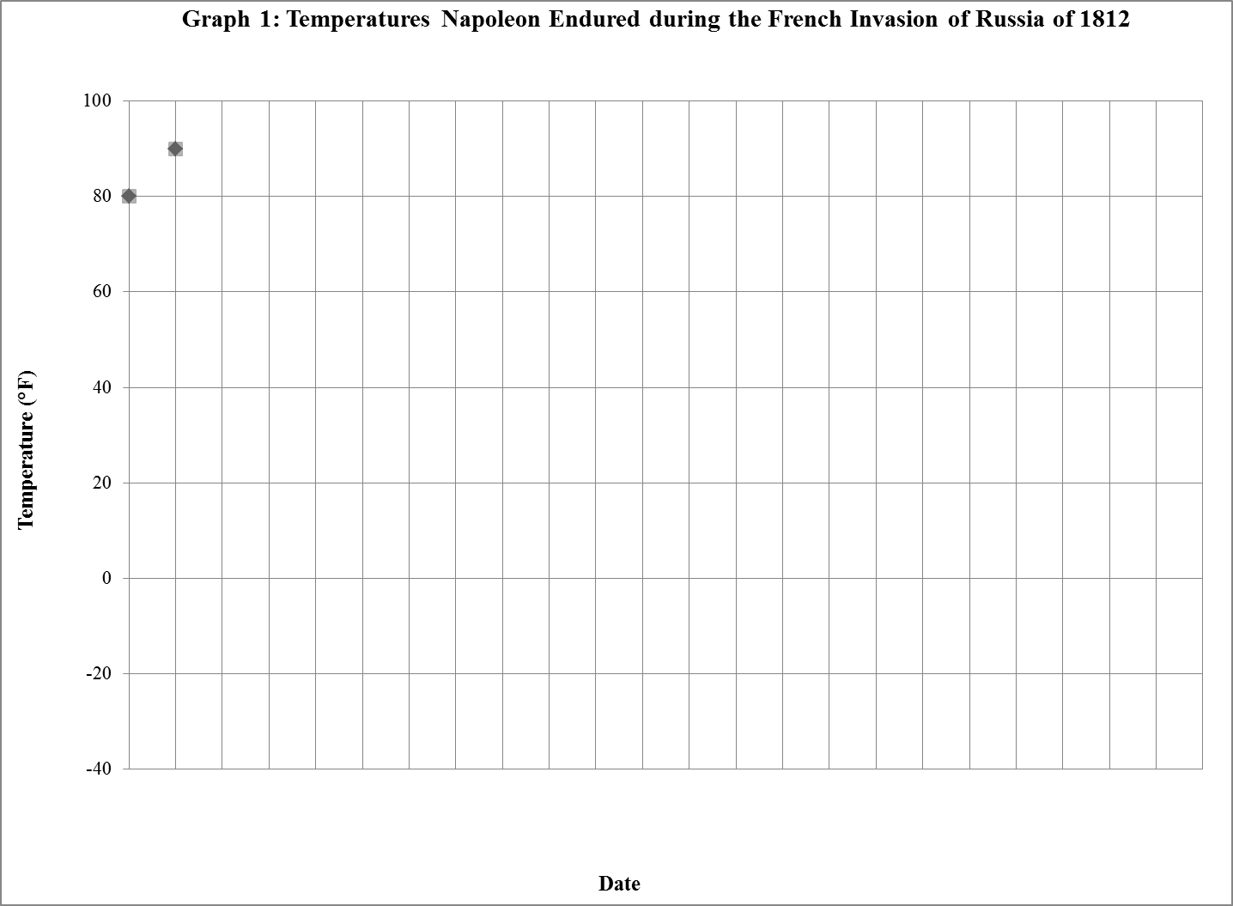

|  |  |  |  |  |  |  |  |  |  |  |  |  |  |  |  |  |  |  |  |  |  |  |  |
| --- | --- | --- | --- | --- | --- | --- | --- | --- | --- | --- | --- | --- | --- | --- | --- | --- | --- | --- | --- | --- | --- | --- | --- |
| 6-24 | 6-28 |  |  |  |  |  |  |  |  |  |  |  |  |  |  |  |  |  |  |  |  |  |  |

**Do You Understand?**

1. Did weather affect Napoleon’s trip? Please explain.

2. What time period had the most drastic change in temperature?